1. Introduction to Operating Systems & the Kernel
An Operating System (OS) is structurally organized as:
$$\text{OS}=\text{Kernel}+\text{System Libraries}+\text{User Interface}$$
- The Kernel: The core component and "heart" of an operating system. It directly manages hardware resources and provides essential services to user applications.
- Core Responsibilities: Process management, file management, network management, and memory management.
- System Layering:
  - Application$\$\backslash rightarrow\$ OS Services / System Libraries \$\backslash rightarrow\$ Kernel \$\backslash rightarrow\$$ Hardware.
System Architecture Layers
Component | Description | Example
Firmware | Low-level software flashed on hardware. | BIOS/UEFI in PCs, uBoot.
Kernel | Core software managing CPU, memory, and devices. | Linux Kernel (vmlinuz), Windows NT Kernel.
Operating System | The complete software ecosystem. | Ubuntu, Android, Windows 12.
2. Kernel Programming for Embedded Engineers
Objectives & Importance
Kernel programming involves developing the core OS software that manages hardware, memory, processes, interrupts, and device drivers.
- Why it Matters:
  - Develop and debug device drivers (e.g., $I^2C$, SPI, UART, PCIe).
  - Enable clean communication between hardware and applications.
  - Optimize performance, latency, power consumption, and footprint.
  - Debug kernel crashes, boot issues, and memory problems.
  - Support firmware interfaces such as SCMI, ACPI, and Device Trees.
- Embedded Applications: Automotive systems, IoT devices, ARM servers, networking equipment, and industrial controllers.
- Key Skills Required: Linux kernel, Device Drivers, ARM64 architecture, Memory Management, Interrupts, and Kernel Debugging.
3. Types of Kernels
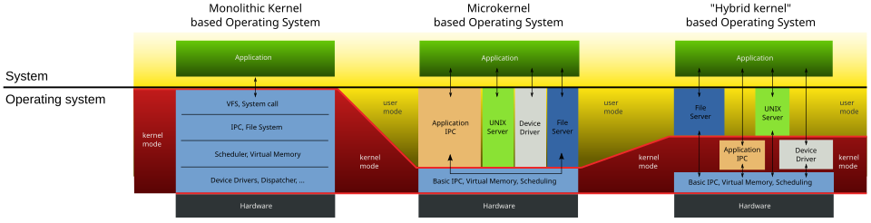
Different OS architectures split responsibilities between user space and kernel space differently:
1. Monolithic Kernel (e.g., Linux, Ubuntu)
- Architecture: All OS services (File System, Directory, Device Drivers, Process Management, Memory Management) run inside a single, massive kernel space.
- Characteristics: Fast performance due to direct communication, but a crash in one subsystem can crash the whole kernel.
2. Microkernel (e.g., Minix3, QNX)
- Architecture: The kernel is stripped down to bare essentials: Basic IPC (Inter-Process Communication), memory, and scheduling.
- Characteristics: File servers, device drivers, and applications run in separate, isolated User Spaces. Highly safe and modular; if a driver crashes, the system survives.
3. Hybrid Kernel (e.g., Windows NT, macOS)
- Architecture: A balanced approach combining aspects of monolithic and microkernel architectures to maintain speed while isolating certain critical tasks.
4. Exo & Nano Kernels (e.g., Adeos, ERIKA)
- Architecture: Ultra-minimalist architectures providing raw hardware access or exceptionally small footprints for specialized embedded systems.
Feature | Monolithic Kernel PDF+ 3 | Microkernel PDF+ 4 | Hybrid Kernel PDF+ 2 | Exokernel PDF | Nanokernel PDF
Core Architecture Design | All OS services and drivers run inside one massive kernel space. | Kernel contains only bare essentials (IPC, basic memory, scheduling). | Combines a monolithic speed architecture with microkernel structural isolation. | Decouples resource protection from management; provides raw hardware access. | Ultra-minimalist layer tracking hardware timers and basic execution loops.
Location of Drivers & File Systems | Kernel Space | User Space (isolated as server applications) | Mostly Kernel Space for performance, but components can be modularized. | User Space (libOS / library operating systems handle them). | User Space or an external architecture abstraction layer.
Inter-Process Communication (IPC) | Fast direct system calls (no context switching needed between subsystems). | Slower; heavily relies on message passing/IPC between user-space servers. | Balanced IPC; optimized paths for critical kernel-level performance. | Minimal; tasks manage their own resources directly via low-level library wrappers. | Extremely low-level tracking overhead.
System Reliability & Safety | Low: A crash in a single device driver can cause a complete kernel panic. | High: Highly safe and modular; if a driver crashes, the system survives. | Medium-High: Better fault isolation than monolithic, but sensitive to kernel-space bugs. | High: Application failures are isolated to their specific hardware slices. | High: Small code footprint limits vulnerabilities or software faults.
Performance Speed | Fast & Efficient due to running in a unified memory map. | Slower due to frequent context switches between user and kernel space. | Fast; optimized to achieve near-monolithic execution speeds. | Extremely Fast due to the complete elimination of typical OS abstractions. | Highly Optimized but limited to tiny control loops.
Size & Memory Footprint | Large code size and high memory consumption. | Small, stripped-down kernel footprint. | Moderate to Large size. | Exceptionally small footprint. | The smallest possible footprint (nano-scale).
Primary Real-World Examples | Linux (Ubuntu, Android) | QNX, Minix3 | Windows NT, macOS | Adeos | ERIKA Enterprise

4. Linux Kernel Architecture & Subsystems
The Linux kernel uses a layered approach to handle requests safely via the System Call Interface (SCI).
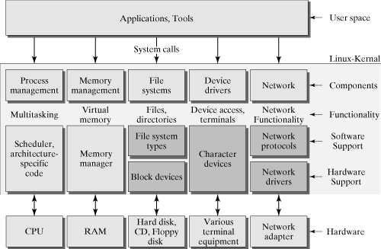
Essential Kernel Subsystems
- Process Management: Manages CPU multitasking, scheduling, and lifecycle.
- Memory Management: Handles virtual memory allocation, page faults, malloc mapping, and physical memory layout.
- Virtual File System (VFS): Provides a uniform abstraction interface for different file system types (e.g., ext4, XFS).
- Device Driver Framework: Standardizes interaction with hardware devices (Character, Block, Network).
- Interrupt Handling: Processes hardware signals dynamically (e.g., keyboard presses, network packet arrivals).
- Network Stack: Implements communication protocols like Ethernet, TCP, and UDP.
- IPC (Inter-Process Communication): Allows processes to sync and talk via pipes, shared memory, and sockets.
- Security Framework: Enforces access control capabilities (e.g., SELinux).
- Power Management: Optimizes power via operations like Suspend and Resume.
- Architecture-Specific Code: Tailors kernel operations to physical hardware (e.g., ARM64 exception handling, MMU setup).
5. Linux Kernel Source Tree
The source tree is divided cleanly into directories representing different hardware and software layers. Analyzing this tree helps you trace subsystem interactions, write device drivers, and debug issues faster.
Directory | Purpose
arch/ | Architecture-specific code (e.g., x86, ARM64).
drivers/ | Code for hardware device drivers (e.g., USB, PCI, Graphics).
fs/ | Virtual File System (VFS) and actual file systems (e.g., ext4).
kernel/ | Core subsystem logic (scheduler, process control).
mm/ | Memory management implementations (paging, allocation).
net/ | Networking protocols and stack implementations.
include/ | Kernel header files containing essential APIs.
init/ | Code that manages early kernel startup and initialization.
security/ | Security frameworks and access controls.
documentation/ | Explanatory text and references for developers

